

**Query Types**

**SARDE**

Located within the Cost Research Hub, SARDE (Selected Acquisition Report Data Exploratory) offers analysis-ready SAR data in the form Queries, Legacy SAR Cost Files, and Analytical Tools.

**SAR Queries** allow analysts to query data based on a variety of metadata criteria; queries are linked to the SAR Database in CADE. Users can visualize data, view the milestone schedule for a program, and study the program cost growth by comparing the program initial SAR report to its latest report.

* SARDB Program by General Characteristic
* SARDB Schedules by PNO
* Technical by PNO
* SARDB Performance by PNO
* SARDB Cost by PNO
* SARDB O&S Cost by PNO
* Transposed Technical by PNO
* SARDB CKB Program Batch Query
* SARDB Growth-Distro Analysis
* SARDB RDTE, PROC Growth and Distro Analysis

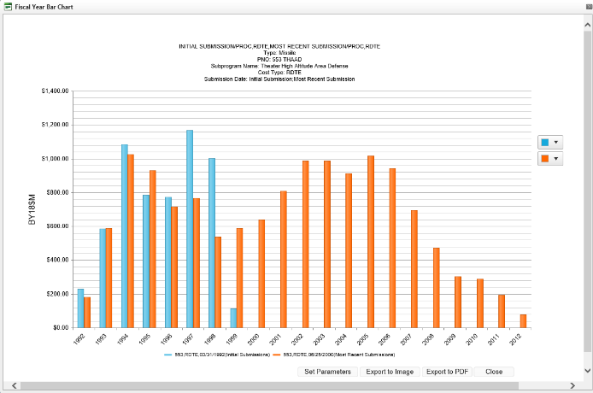

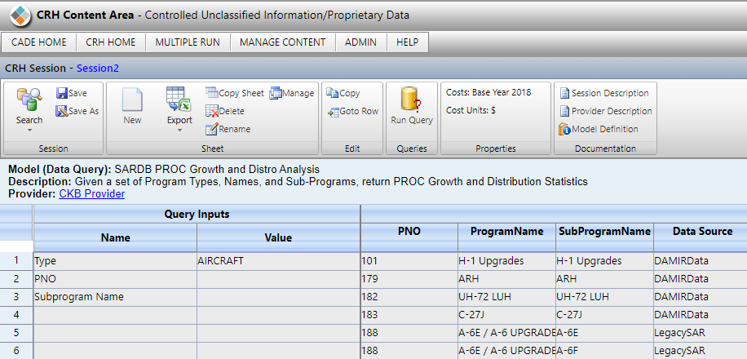

**Analytical Tools** consists of Excel macro SAR Analytic Tools. DASA-CE sponsored a SAR analysis in the mid 2015’s, resulting in three utilities to examine SAR data:

* Time Phasing
* Cost Improvement Curves
* Cost Growth

The utilities format the SAR data in CO$TAT worksheets where you can run various analysis. Instructions for each utility are provided.

**Legacy SAR and Cost File**

**Legacy SAR** provides an archive of original SAR Reports used in some DASA-CE SAR studies. The archive offers quick access to the reports organized by program.

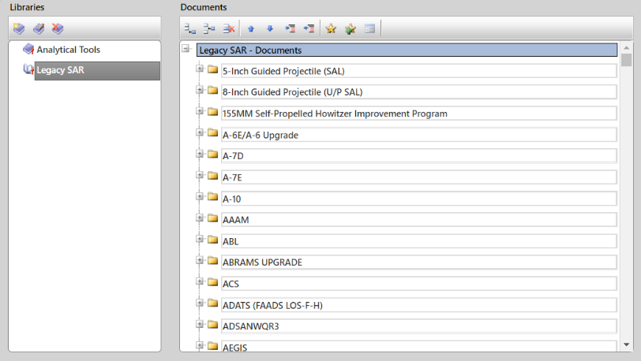

**Time Phasing Tool**

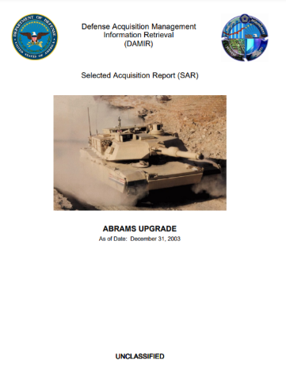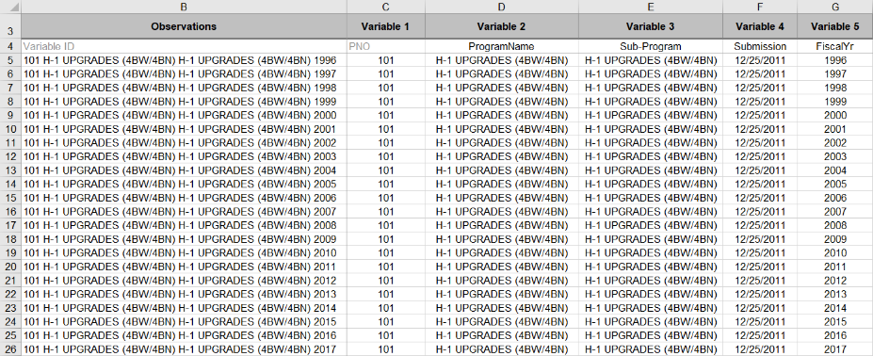

CRH is sponsored and administered by the Office of the Deputy Assistant Secretary of the Army – Cost & Economics (DASA-CE) CRH Support is provided by Tecolote Research at: [CRH_Support@Tecolote.com](mailto:CRH_Support@Tecolote.com)

.



* CRH is available through CADE at https://cade.osd.mil
* CRH is listed under Analyst Applications