

**ACDB+**

Located within the Cost Research Hub, **ACDB+** (Automated Cost Database Plus) provides analysis-ready data based on contractor CDSRs, FCHRs, CPRs, and technical data for four Army-focused commodity databases:

* Aviation
* Communication & Electronics
* Missiles & Munitions
* Wheel & Tracked Vehicles

In addition to the database, ACDB+ includes cost studies, CERs, and database flat files.

**ACDB** provides access to raw, mapped, and mapped normalized data. Users can retrieve data based on database import structure (WBS, CES, etc.). Data can be downloaded in these basic formats as well as through analysis reports. Downloads are compatible with Excel and CO$TAT, allowing analysts to develop CERs, generate learning curves, perform uncertainty analyses, and more.

**ACDB General Workscreen**

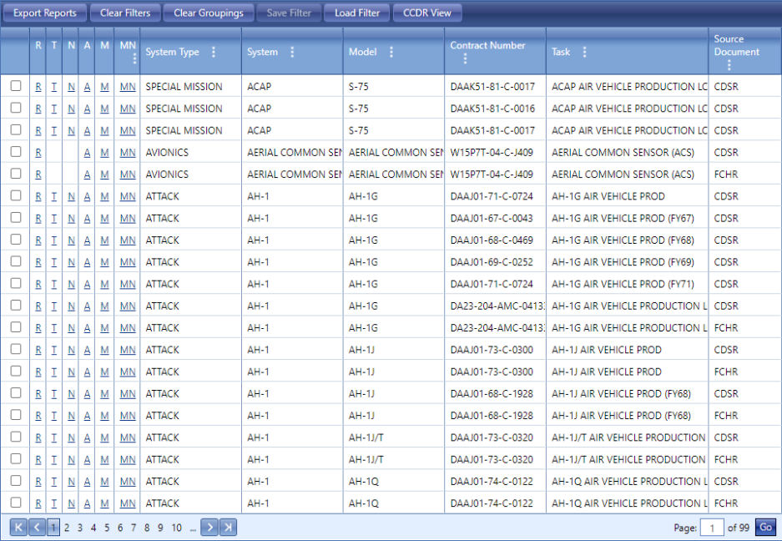

**ACDB Analysis Reports**

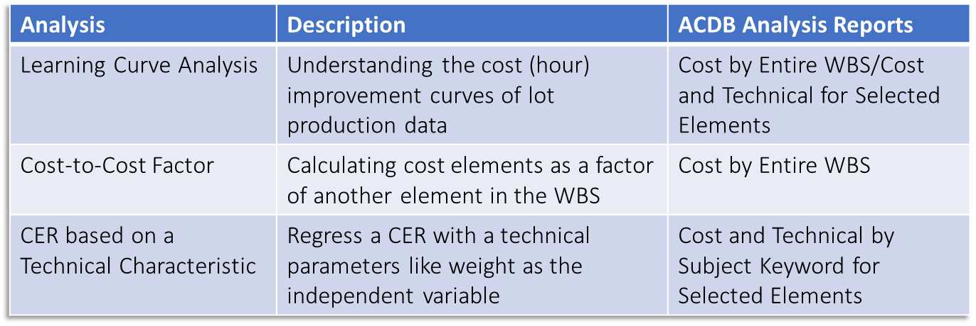

**Bulk Data Flat Files** efficiently allows government analysts to download a Pivotable Excel file of all records within each of the four databases. This data can then be analyzed with Pivot Tables or other methods. It can be exported into environments like Power BI for visualizations and cross database analysis.

The **Cost Study Center** is the home for ACDB Cost Studies as well as their corresponding CERs. CERs and factors include equations and documentation on the aforementioned databases. Hosted CERs can be downloaded directly into ACE sessions.

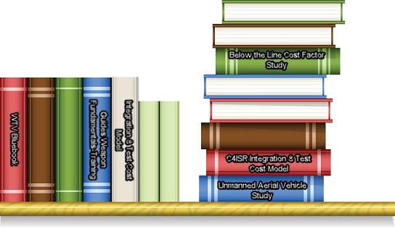

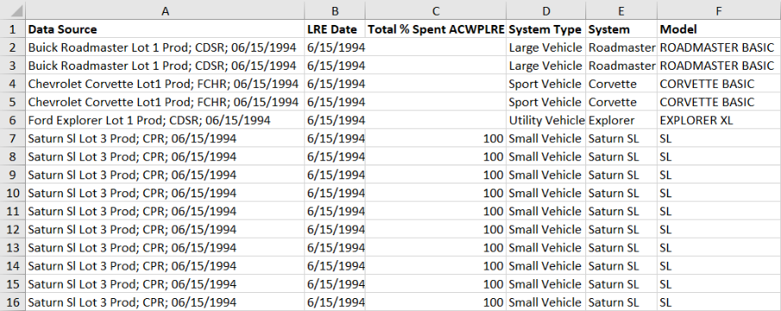

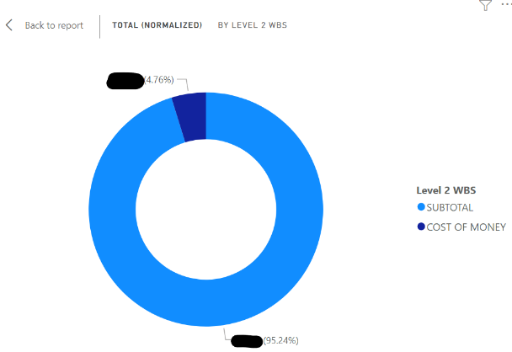



CRH is sponsored and administered by the Office of the Deputy Assistant Secretary of the Army – Cost & Economics (DASA-CE) CRH Support is provided by Tecolote Research at: [CRH_Support@Tecolote.com](mailto:CRH_Support@Tecolote.com)

.



* CRH is available through CADE at https://cade.osd.mil
* CRH is listed under Analyst Applications