**PROFESSIONAL CERTIFICATION APPROVAL FOR REIMBURSEMENT FORM – ENCL 1**

**Privacy Act Statement**

The following information is provided to comply with Privacy Act of 1974 (PL 93-579). Authority: 5 USC 5757: NOAA FY 2002, §112; PL 107-107 and NOAA 2012, §1051; PL 112-81. Principle Purpose (s): Information collected on this form will be used to reimburse the requesting applicant for expenses incurred to obtain professional financial management credentials **Routine Use(s)**: To substantiate claims for reimbursement for professional financial management credentials. The employee requesting reimbursement under this authority must have written approval from the appropriate approving official prior to incurring the expense. **Disclosure**: Voluntary; however, failure to furnish information requested may result in denial of amount claimed and may prevent the receipt of payments through the electronic funds transfer or deployable disbursing system (ETS/DDS) programs.

**APPLICANT COMPLETES THIS SECTION:**

Name: __________________________________________ Series/Pay Grade: ____________

Organization: ________________________________Signature:________________________ Work Phone#: _____________________________

|  |  |  |  |
| --- | --- | --- | --- |
| **Certification or License Name** |  | **Certification or License Name** |  |
| **Expense(s) and Date Expense(s) occurred:** |  | **Expense(s) and Date Expense(s) occurred:** |  |
| **Registration Fee:** |  | **Registration Fee:** |  |
| **Examination Fee:** |  | **Examination Fee:** |  |
| **Renewal Fee:** |  | **Renewal Fee:** |  |
| **Total** |  | **Total** |  |
|  |  |  |  |
| **Certification or License Name** |  | **Certification or License Name** |  |
| **Expense(s) and Date Expense(s) occurred:** |  | **Expense(s) and Date Expense(s) occurred:** |  |
| **Registration Fee:** |  | **Registration Fee:** |  |
| **Examination Fee:** |  | **Examination Fee:** |  |
| **Renewal Fee:** |  | **Renewal Fee:** |  |
| **Total** |  | **Total** |  |

***Note: if multiple exams are required for a certification shows each exam separately.*** 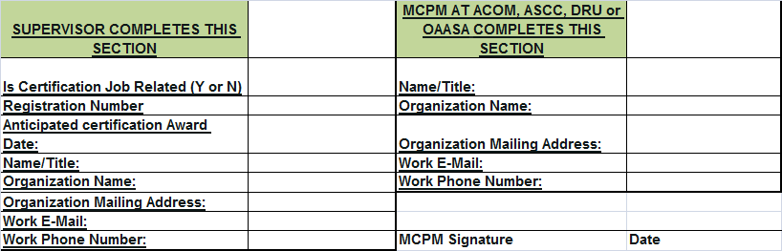

**Supervisor Reimbursement approval – attach proof documentation:**

Name/Grade/Signature:___________________ __Approve (Y or N): ____

**CP-11 JUNIOR EXECUTIVE COUNCIL MEMBER COMPLETES THIS SECTION (not to exceed funding allocated and provides completed form to the Army Proponency Office):**

CJEC Name/Grade/Signature:___________________ __Approve (Y or N): ____